Topics covered –

* Currency converter web automation using Excel
* Exception, Recover, Resume stages

If we don’t add any fields when creating a collection stage, then it will automatically create one post running

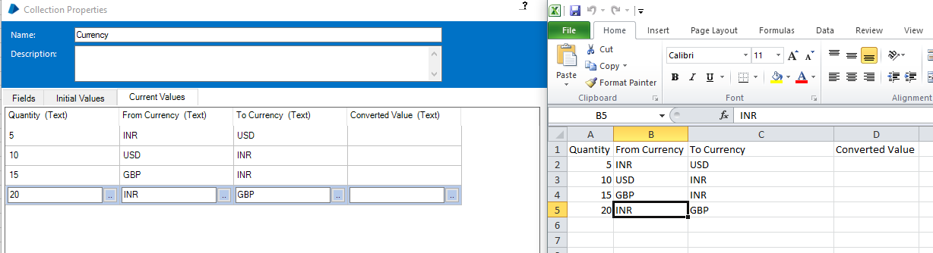

Convert Currency is a separate page which requires 3 inputs.Since we have not added column to collection, those fields will not show under data item. Manually add them in the value column making sure column name is same as in excel

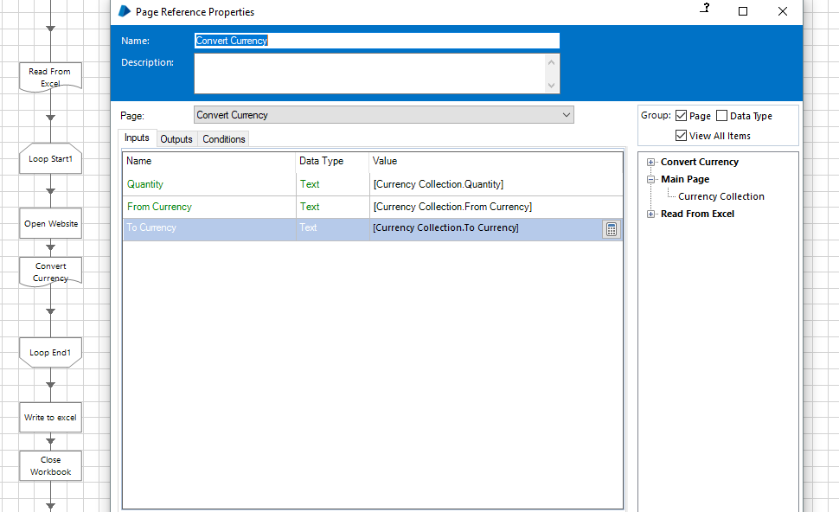

Always run in fast mode to identify page timeout issues

For closing the browser, use Terminate Action under Navigation Stage

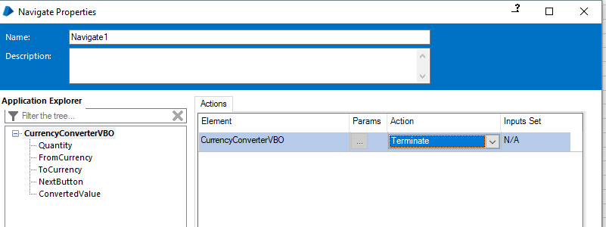

The Refresh button (underlined in blue) –

If u make changes to your object which is being used in the process and you want these changed to be updated and available in your current working page with saving and reopening, then click refresh



Add exception handling to close excel instances

Would close all instances – close previous instances as well from task manager? No

Reset icon – will release all the resources from task manager(verified).

Just saving the excel will not write to collection, we have to use “Write Collection” action of MS Excel VBO before that

**Exceptions**

To catch the exception, use recover stage. It acts like a magnet which would catch any exception and its not linked to any stage. We can log exceptions caught in this stage to data items using calc stage

Recover – Calc -- Resume

To resume flow to a specific stage, use resume stage

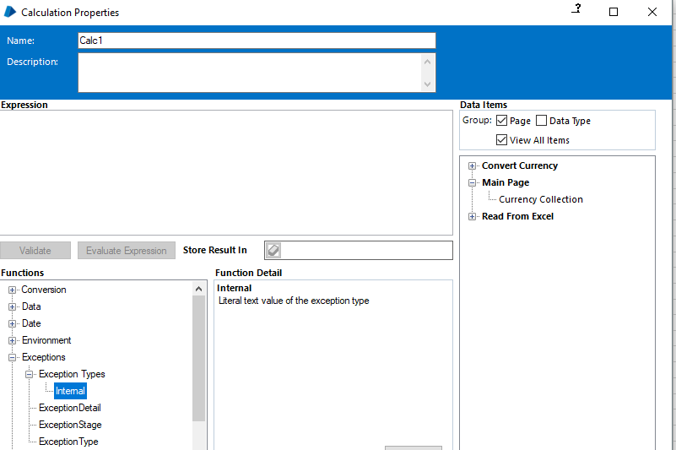

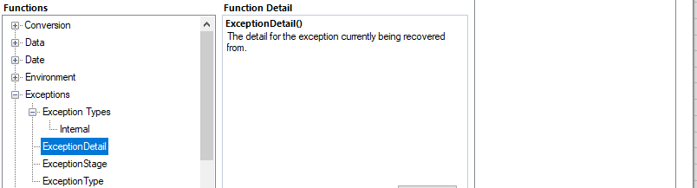

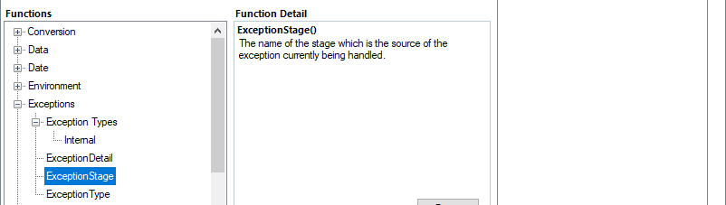

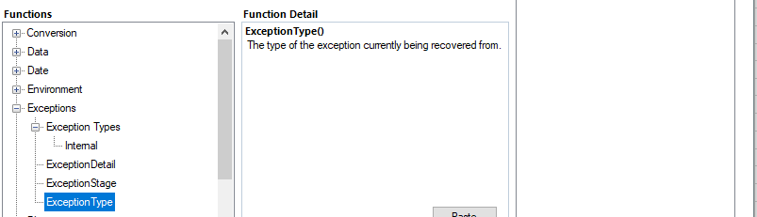

Can refer foundation training course pdf

Modify “From currency” attributes from application modeller in object studio so that it throws error

**ExceptionDetail** function will capture all the details of the function and we can store in a text variable

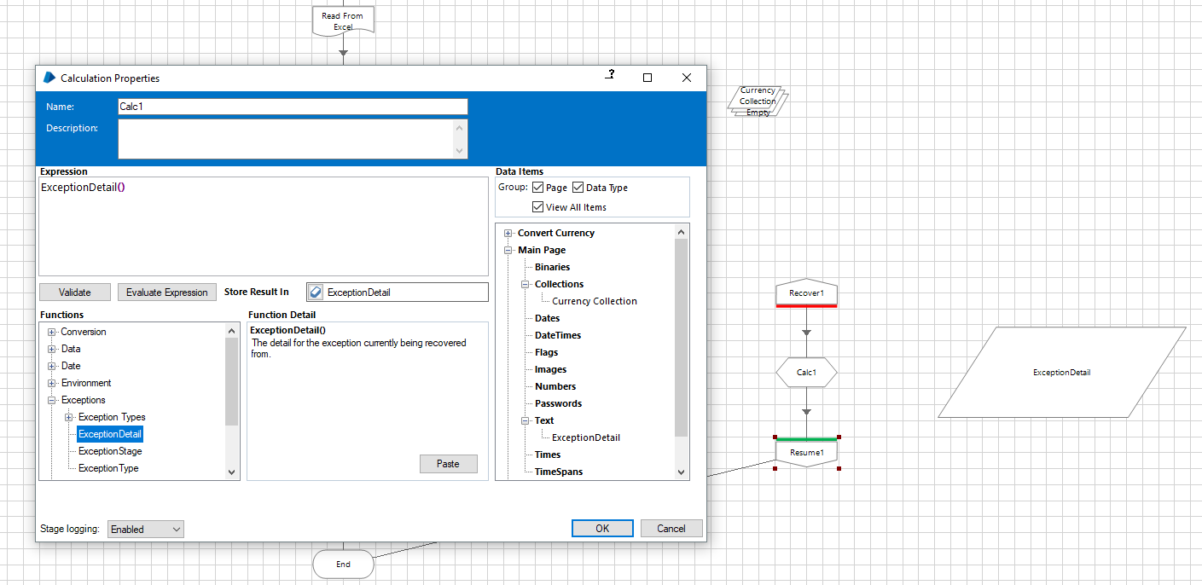

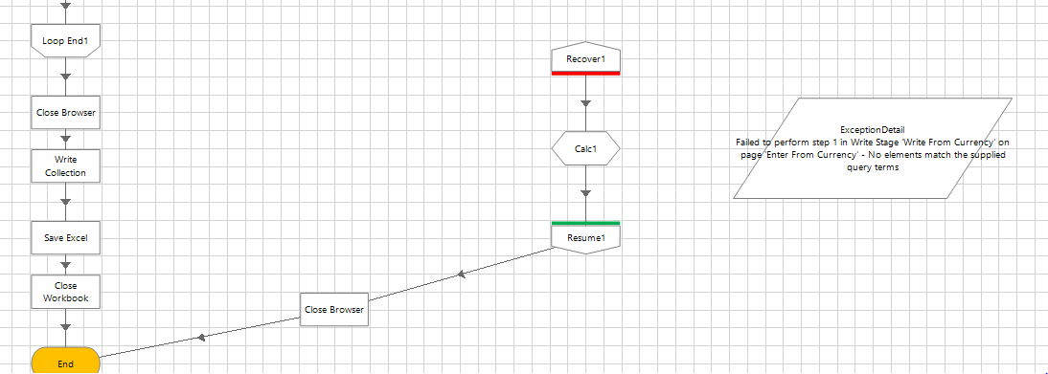

“Failed to perform step 1 in Write Stage 'Write From Currency' on page 'Enter From Currency' - No elements match the supplied query terms”

Pending :- Can we catch specific exceptions only (for eg Divide by zero), because based on the exception the recovery may change. Using decision stage?

Writing exceptions to excel or some central repository

Use exception stage to write into the exception detail field. Exception stage doesn’t need to be linked to End or any other stage

Pending: Go through all VBOs

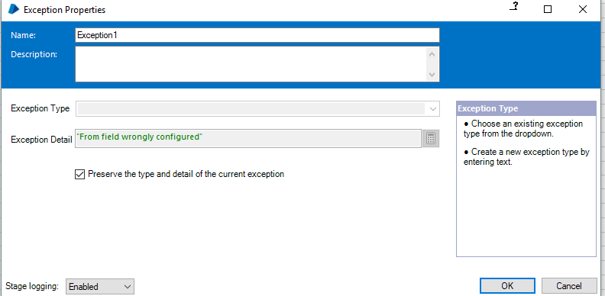

“Preserve the type and detail of the current exception:” If checked, then it will use type and details of the original exception (both fields gets disabled)– “Failed to perform step 1 in Write Stage 'Write From Currency' on page 'Enter From Currency' - No elements match the supplied query terms” (verified)

If we don’t use resume stage, BP will give an error that it is linked back to main process without using resume stage

Recovery stage cannot be linked back to main process directly. It needs resume stage or Exception stage. We cannot create a link ‘from’ exception stage

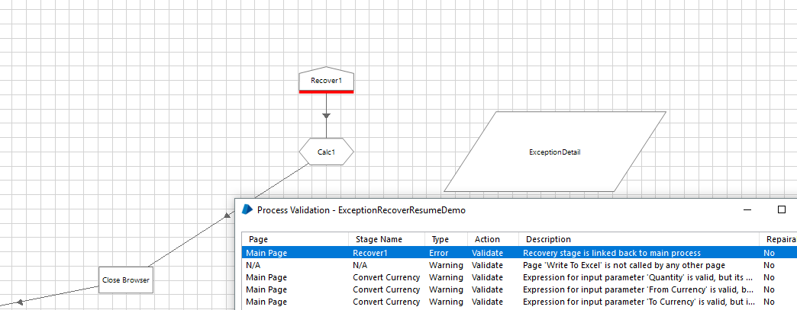

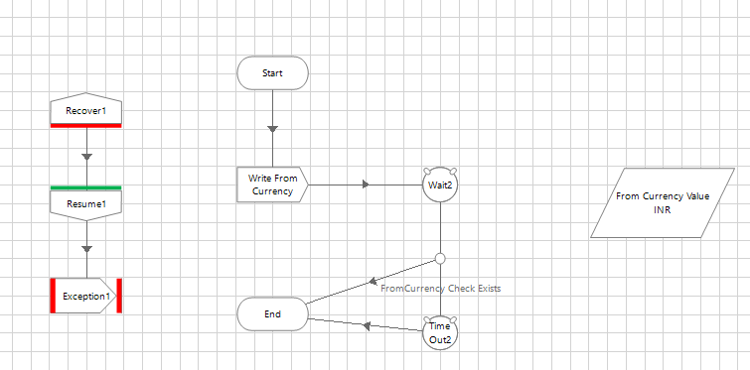

This would go in an infinite loop, because Recover will again catch the Exception thrown

To avoid this, use block stage to associate Recover with only Write from currency stage. So it would only attract exceptions from that stage

Pending from Amit : Companies have standards how to log messages in exception

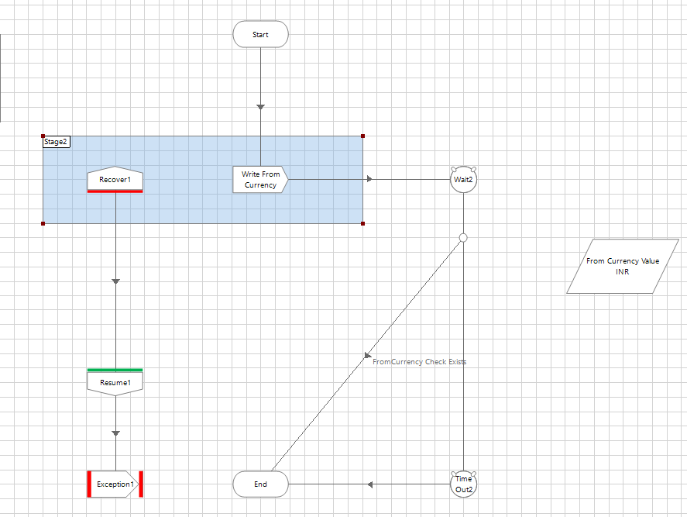

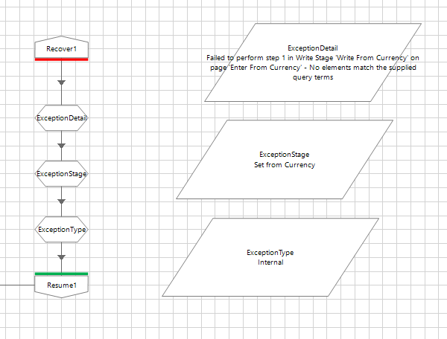

Using calc stage to display other functions under exception category – viz ExceptionStage() ExceptionType()

For the custom exception

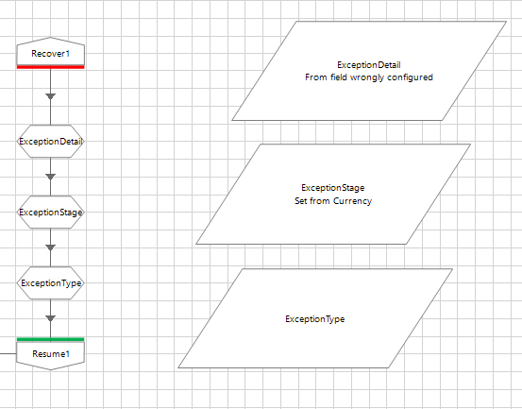

Pending: Difference between exception types/type function in calc stage

Interviews : most question from exception handling

Page stage –

New Page wizard :

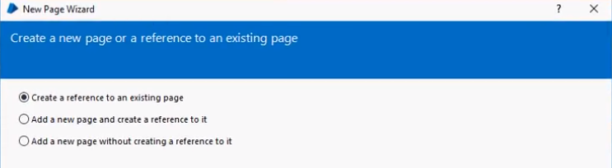

**Configuring Outlook:Pending**

BluePrismMapiEx1.1.15.msi – install this first, but this only works with 32 bit version of outlook

Configure gmail in outlook

Go to System tab in blue prism > Objects >External – set the following name and class

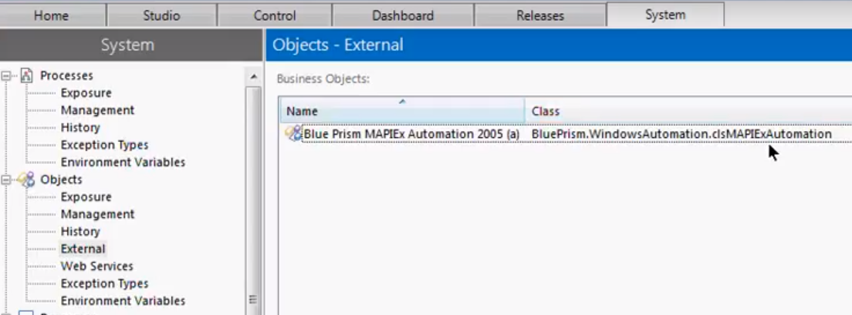

Use add object on the right to add this

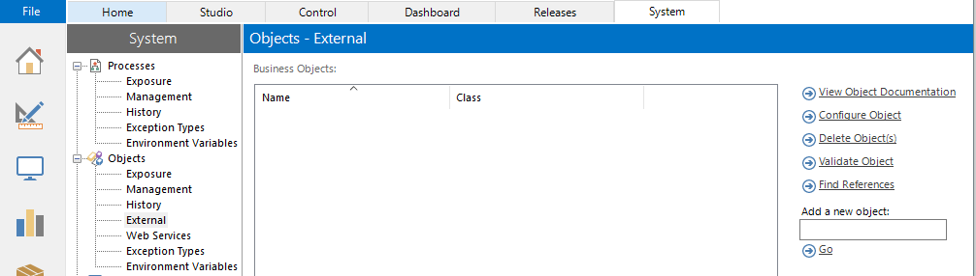

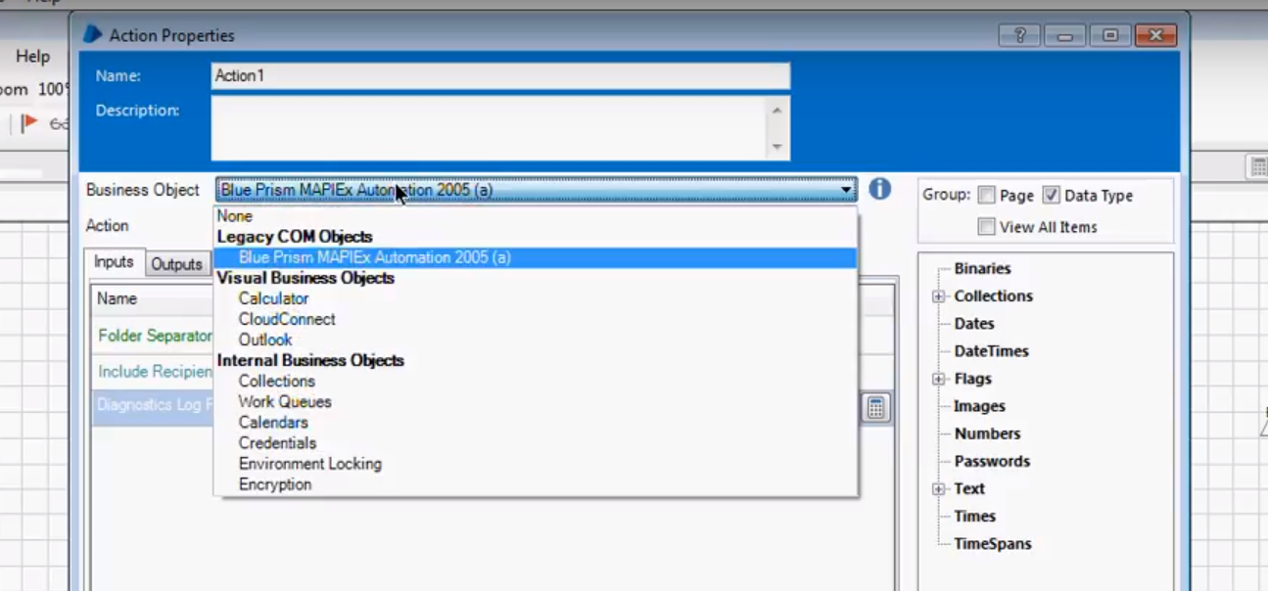

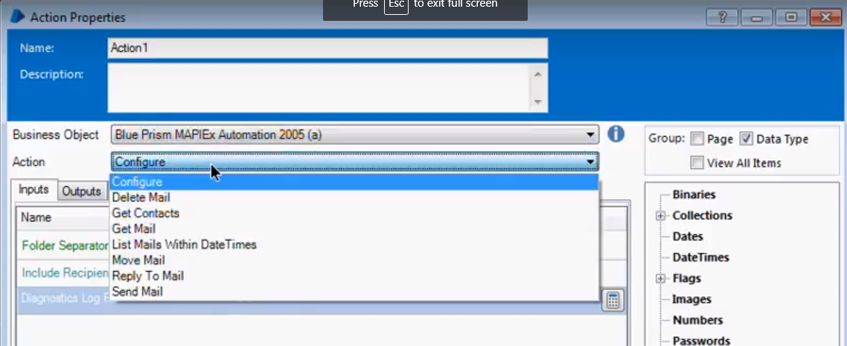

Keep configuration options unchanged

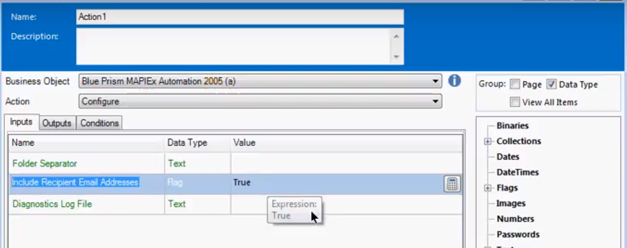

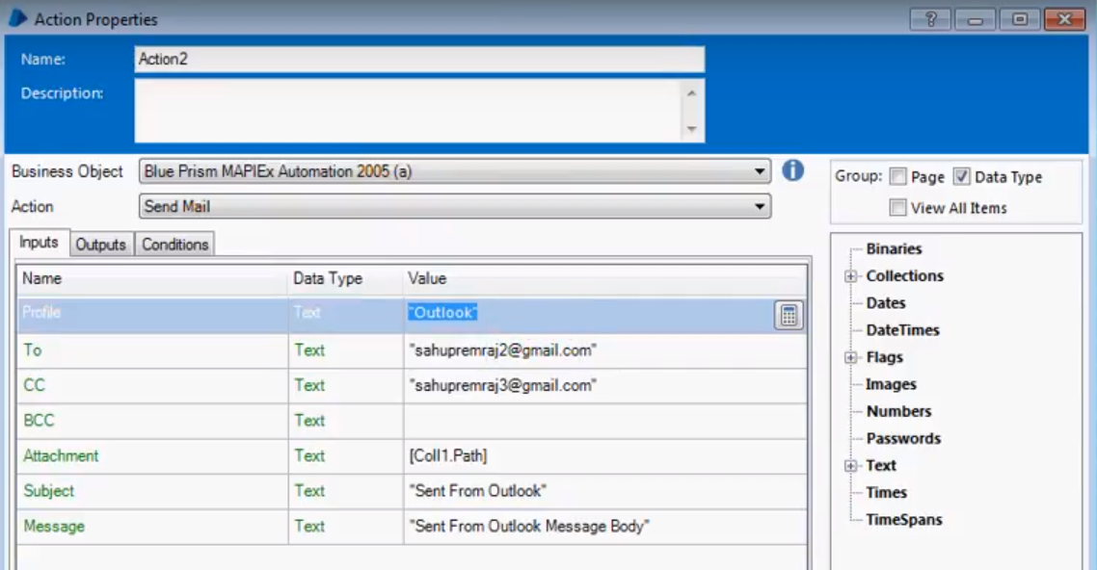

For getting the profile value, go to control panel, search for outlook

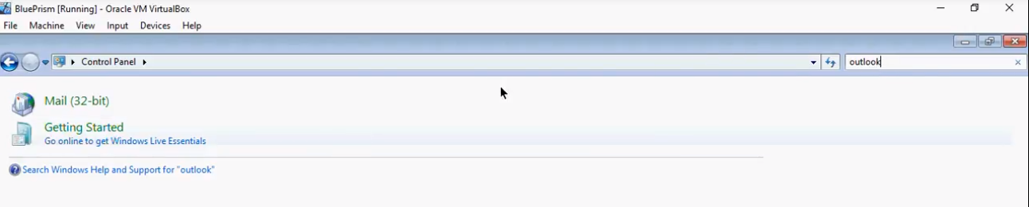

Click on Mail (32-bit) > Show Profiles

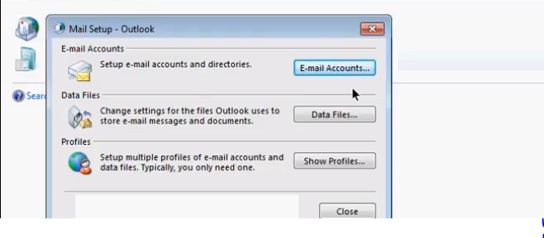

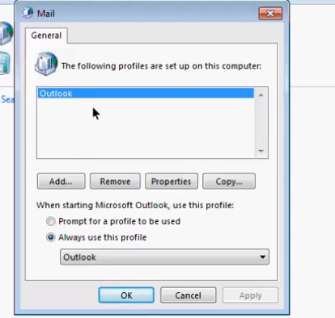

Configuring attachments

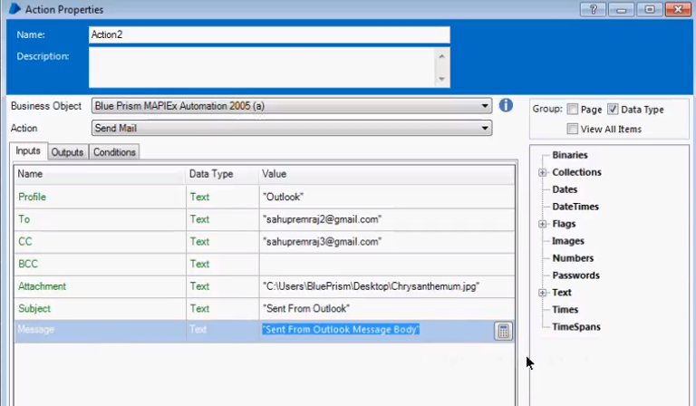

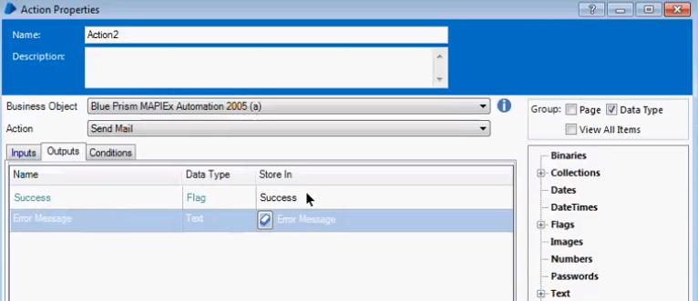

Success(boolean) and error(text) message variables will appropriately get populated on success/fail

